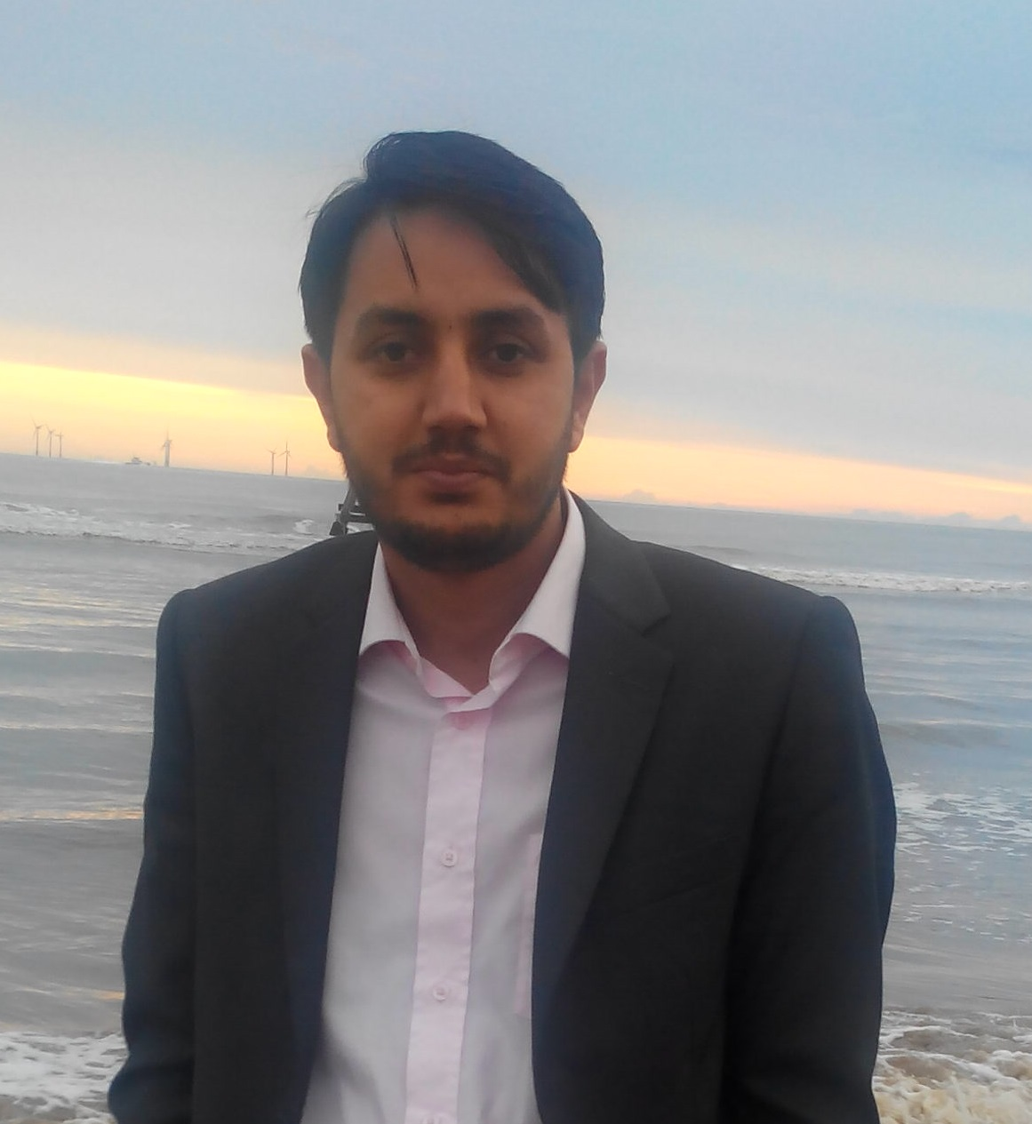
Curriculum Vitae

Dr. Haider Ali
Office: +92919221038.
Cell: +923459234592.
Address: Department of Mathematics, University of Peshawar.
Email: dr.haider@uop.edu.pk

Research & Teaching Interests:

Variational Models in Image Segmentation, Modelling in Image Processing, Medical Image Analysis, Computational Methods.

Ph.D. (2016): Applied Mathematics (Image Processing)

PhD research work was carried out in the Department of Mathematics, University of Peshawar, Pakistan under the title “Efficient Variational Models in Image Segmentation and Applications”. This research work was carried out in guidance of Professor Ke Chen, Liverpool University, England.

The following are some projects which are published.

Project#1: www.sciencedirect.com/science/article/pii/S0031320315003106

Project#2: www.sciencedirect.com/science/article/pii/S003132031600042X

MS (2012): Applied Mathematics (Image Processing)

The MS research work was carried out in Department of Basic Sciences, University of Engineering and Technology, Peshawar, Pakistan under the title “Variational Models in Image Segmentation”. This research work was also carried out in guidance of Professor Ke Chen.

The following project was accomplished.

Project#3: ftp://ftp.liv.ac.uk/pub/maths_chen/chen/Noor_31.pdf

M.Sc. (2007): Mathematics

Masters in Mathematics (Session 2007), Department of Mathematics, University of Peshawar, Pakistan.

B.Sc. (2004): Mathematics

Graduation in Mathematics and Statistics (Session 2004), University of Peshawar, Pakistan.

Employment History:

• Lecturer in Mathematics, Department of Mathematics, University of Peshawar, Pakistan, from 14 October 2010 to till date.

• Lecturer in Mathematics, Qurtuba University of Science and Technology, Peshawar, Pakistan from 15th August 2008 to 28th September 2010 as a regular faculty member.

Published/accepted and submitted research work:

[1] Multiphase segmentation based on new signed pressure force functions and one level set function. Haider Ali, Noor Badshah, Gulzar Ali Khan, Nosheen. Turkish Journal of Electrical Engineering & Computer Sciences, 2017.
http://journals.tubitak.gov.tr/elektrik/issues/elk-17-25-4/elk-25-4-33-1606-260.pdf

[2] A New Variational Segmentation Model with Hybrid Images Data Fitting Energies. Haider Ali, Noor Badshah, Ke-Chen, Gulzar Ali Khan. Pattern Recognition 2015.

Online: www.sciencedirect.com/science/article/pii/S0031320315003106

[3] Active contours textural and inhomogeneous object extraction. Lutf-Ul-Mabood, Haider Ali, Noor Badshah and Ke-Chen. Pattern Recognition 2016.

Online: www.sciencedirect.com/science/article/pii/S003132031600042X

[4] Coefficient of Variation Based Image Selective Segmentation Using Active Contour. Noor Badshah, Ke-Chen, Haider Ali and Ghulam Murtaza. East Asian Journal on Applied Mathematics 2012.

Online: ftp://ftp.liv.ac.uk/pub/maths_chen/chen/Noor_31.pdf

[5] Image Segmentation Based on Robust Fidelity Terms for Noise+Intensity Inhomogeneity. Haider Ali, Noor Badshah and Lavdie Rada. Submitted to IEEE, 2017.

http://www.journals.elsevier.com/biomedical-signal-processing-and-control/

[7] Dual Filter Formulation for Image Intensity Inhomogeneity Reduction with Application to Image Segmentation. Haider Ali, Muhammad Salim Khan and Noor Badshah. Submitted to Pattren Recognition, 2017.

http://www.springer.com/computer/image+processing/journal/10851

[8] A Robust Local Model for Segmentation Based on Coefficient of Variation. Haider Ali, Noor Badshah and Ghulam Murtaza. Journal of information & Communication Technology 2011.

Online: http://biztek.edu.pk/ibt/images/JICT/5X1/4%20FA%20Robust%20Local.pdf

[9] Covariance Based Image Selective Segmentation Model. Ghulam Murtaza, Haider Ali, Noor Badshah. Journal of information & Communication Technology, 2010.

Online: http://biztek.edu.pk/ibt/images/JICT/4X2/2%20Covariance%20Based%20Image.pdf

Conference Presentations:

- 11th Islamic Countries Conference on Statistical Siences (ICCS-11), Lahore, Pakistan, 2011.

- International Conference on Modelling and Simulation Air University Islamabad Pakistan, 25-27 November, 2013.

International Conference Papers:

[1] Covariance and Local Statistical Functional Equiped Robust Variational Model for Image Selective Segmentation. Haider Ali, Noor Badshah, Ghulam Murtaza.

Proceedings of 11th Islamic Countries Conference on Statistical Siences (ICCS-11). Vol. 21, pp. 471-482, 2011.

[2] Local Badshah-Chen Model for Image Selective Segmentation. Haider Ali, Gulzar Ali Khan, Nosheen, Noor Badshah.

International Conference on Modeling and Simulation Air University Islamabad Pakistan, 25-27 November, 2013.

[3] New Variational Model for Vector Valued Image Segmentation. Noor Badshah, Fahim Ullah, Haider Ali.

International Conference on Modeling and Simulation Air University Islamabad Pakistan, 25-27 November, 2013.

Students Supervision:

Supervision of several Master level students at University of Peshawar who have conducted good research work; for reference see
www.sciencedirect.com/science/article/pii/S003132031600042X

Currently, five MS and four BS level students are working in my supervision.

Research Team:

I am working in collaboration with Dr. Noor Badshah and Professor Ke Chen of CMIT, Liverpool University, Liverpool, UK from last 5 years.

http://www.liv.ac.uk/~cmchenke/

Foreign Visits:

- I have been invited by the Department of Mathematics, Liverpool University, Liverpool, UK, for collaborative research work at CMIT in April, 2014.

References:

References can be provided on request.

